**Lab 1 – Building and Using Your Own Radiometer**

Yuval Levental, Group 4RIT Center for Imaging Science, 54 Lomb Memorial Drive Rochester, NY 14623

**ABSTRACT**

This lab served as an introduction to using a radiometer. The first part involved designing the circuit layout for a radiometer and measuring the output voltage from an op-amp with a constant light source. The second part involved determining the linearity of the photodiode radiometer. The third part involved measuring the output voltage as a function of dark current and resistance. The final part involved demonstrating the inverse square law by moving a detector away from a fiber optic light source in 1 cm increments and measuring the output voltage of the radiometer. Overall, the equipment seems to be working as expected, and basic radiometry concepts were covered in this lab.1

**Keywords:** Radiometry, op-amp, linearity, dark current, inverse square.

1. **INTRODUCTION**

The purpose of a radiometer is to measure the radiant flux or power of electromagnetic radiation, which is used in many imaging applications. The basic output voltage for testing is calculated through a 741 op-amp, which outputs a voltage as a function of several resistances. The current generated by the photodiode is calculated through Ohm’s Law, *V = IR*.

The radiometer is supposed to be linear, but because the photodiode is not calibrated, linearity is determined by using neutral density (ND) filters in front of the detector, which block various percentages of entering light. The transmission percentage is calculated using 10*(-ND)*, and is compared with the output voltage *Vout* to determine the linearity of the radiometer.

Dark current is noise which is transmitted through the photodiode, independent of any light source. The dark current is also calculated through a 741 op-amp at various resistances using Ohm’s law.

Finally, through collecting voltage measurements from a fiber optic cable placed at various distances, the inverse square law is demonstrated. This law states that if *V1* and *r1* are known from a point source that outputs irradiance, *V2(r2)2 = V1(r1)2*.1

1. **PROCEDURES**

Five resistors are given, which range in value from 1kΩ to 10MΩ. The resistances are measured and recorded. Additionally, two 9V batteries are given, and their voltage is also measured. The radiometer is then constructed on the breadboard as shown in Figure 1.

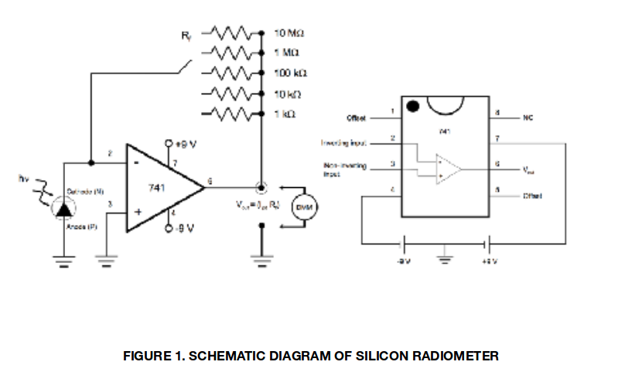

Figure 1. Schematic Diagram of Silicon Radiometer

A tungsten light source is set up to be incident on the radiometer, and the irradiance on the detector must be constant. The room lights are turned off, and all major electronic devices are put away. The output op-amp voltages are measured with respect to each resistance. The photodiode current values are then calculated.

For linearity analysis, the radiometer is set up with the 100kΩ resistance and the light is placed at a distance so that the output voltage is 5V. The ND filters are placed in front of the detector, and the voltage is calculated for each combination. The measured voltage is plotted against 10*(-ND)* and analyzed.

Dark current is then measured. The photodetector is completely covered, and the output op-amp voltages are measured with respect to each resistance. The dark current for each value is then calculated.

The inverse square law is then demonstrated. A fiber optic light on the lens bench is set up at an initial distance of 8 cm from the photodetector, so it can be used as a point source. The brightness is at the lowest setting. The voltages are measured and recorded in 1 cm distance increments from 8 cm to 28 cm. This concludes the lab procedures.

1. **ANALYSIS AND RESULTS**

A saturated signal will occur if the light source brightness is high enough, since the op-amp can only output a 9V maximum. However, there was no saturated signal. In Table 2, the general pattern is that the higher the value of a feedback resistor, the higher the output voltage will be. The calculated current exponentially decreases as a function of increased resistance, since the op-amp gain greatly exceeds proportional resistance gain.

In Table 3, multiple filters are used to test the linearity of the radiometer. If more than two filters are used, virtually no light will be able to pass through, creating disproportionate interference.

Figure 2 is a plot of voltage vs 10*(-ND)*. As the 10*(-ND)* increases, the measured voltage also increases almost linearly. Essentially, the device is linear. 10*(-ND)* is the transmission percentage. The only truly anomalous data point is (0.079, 0.952), because three ND filters are used, which creates too much inter-filter interference. The r-squared coefficient is calculated using Equation 1.2

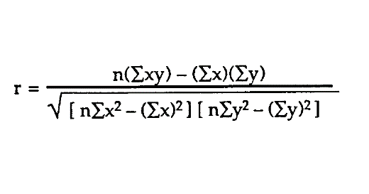 (1)

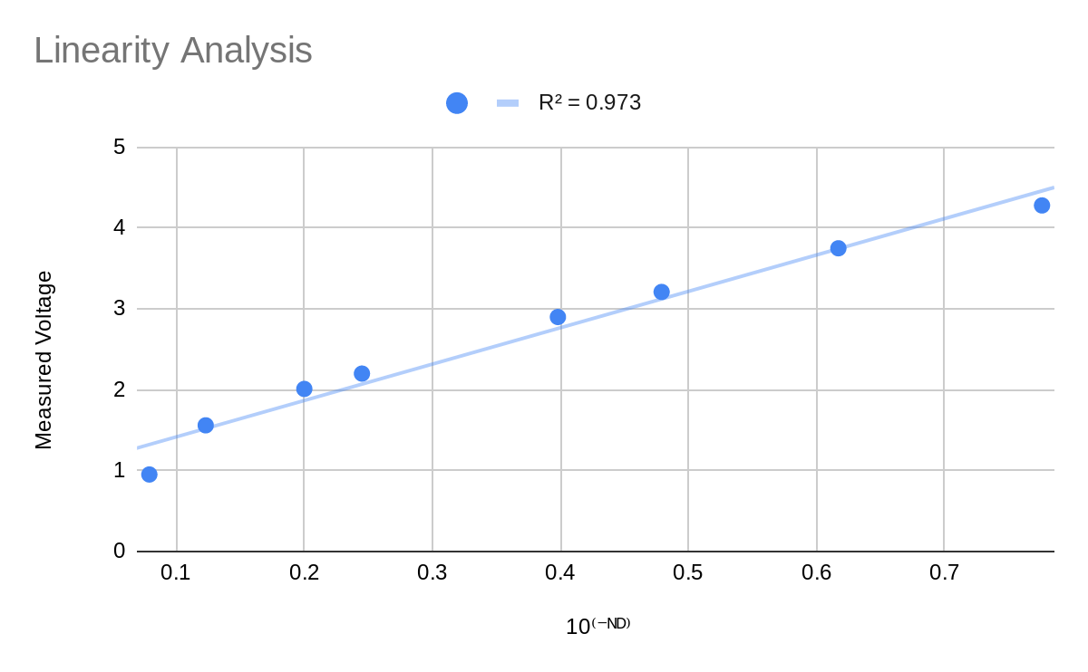

Figure 2. Plot of Linearity Analysis

The dark current was calculated in Table 4. This is calculated using Ohm’s law. Recording the voltage is easy, because the multimeter is very sensitive. Most of the voltages are small, as expected. Additionally, the voltage goes downward as the resistance is increased, as the dark noise also decreases with a greater resistance due to lack of interference.

The inverse square law, *V2(r2)2 = V1(r1)2*, is verified in Table 5, with the calculated differences in voltage for each cm. The source diameter was 8 mm, and the min distance is 8 cm. The predicted voltage has the same second derivative as the read voltage, but the voltage decrease is somewhat greater. The inverse square law general shape is expected, but it is more powerful compared to the read voltage.

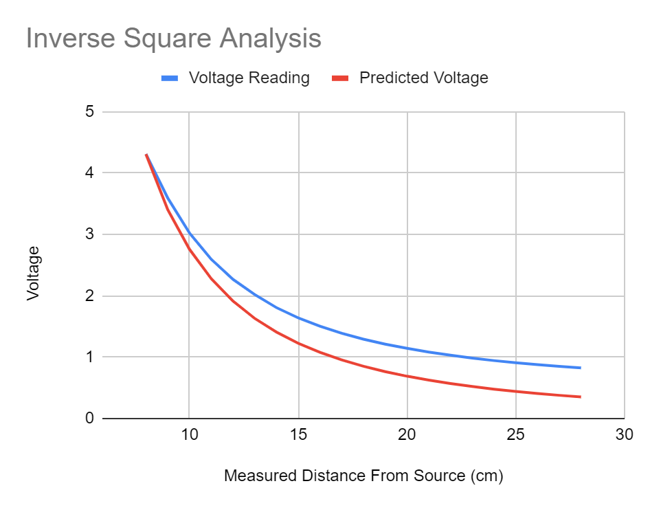

Figure 3. Plot of Inverse Square Analysis.

For the peak normalized plot of voltage, Figure 4, the slope would ideally be the original voltage divided by the initial measurement of 1/r2. The intercept should be y = 0, because as the radius becomes infinite, the voltage drops down to zero.

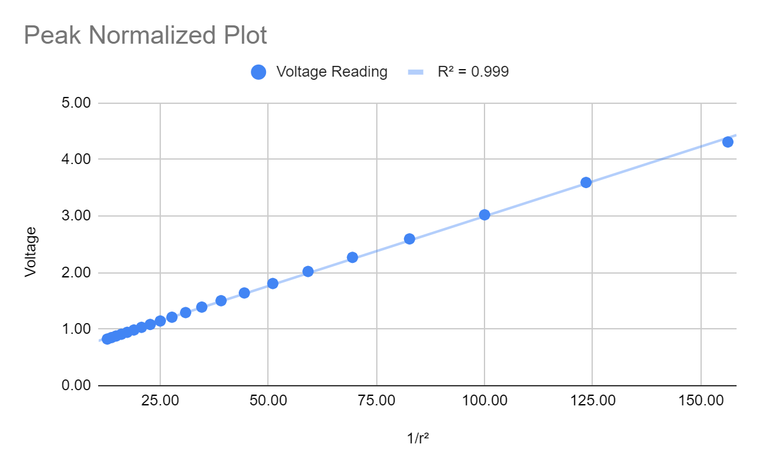

Figure 4. Peak Normalized Plot.

Overall, the radiometer performs as expected. The radiometer works using an op-amp to redirect current using a series of resistors. The 2 9V batteries provide the maximum output voltage. Different resistors create different output voltages. The greater the resistance, the more current flows through the op-amp, creating a higher voltage with a maximum output of 9V.

The greatest problem detected was the dark noise measured inside the photodetector. A noise filter could be added to reduce noise from the photodetector. The dark current is important to consider in situations involving low levels of light, since it is more prevalent. The op-amp amplifies the measured voltage from the photodetector through current flow and battery power, and makes it easy through being able to select an appropriate resistance. The minimum voltage is around 30 mV based on the dark current measurement, and the maximum voltage should be 9V, which is the voltage of the op-amp batteries.

1. **CONCLUSIONS**

In conclusion, the fundamental measurements of a radiometer were performed and analyzed. Gain analysis as a voltage of resistance works as expected, with a maximum output voltage of 9V. The radiometer is very linear, with a maximum of two neutral density filters as verification. Dark current of less than 1V was detected, and the inverse square law fundamentally holds for this radiometer, though the voltages are higher than expected. There can be some possible improvements on the measurements that were made and the design of the radiometer, but this is a good introduction to using a radiometer.

**APPENDIX A. CIRCUIT COMPONENTS AND RAW DATA**

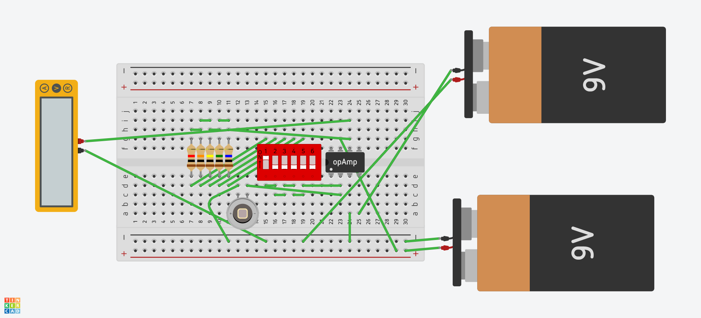

Figure 5. Pre-lab circuit diagram made at tinkercad.com

Table 1. Materials needed for the lab.

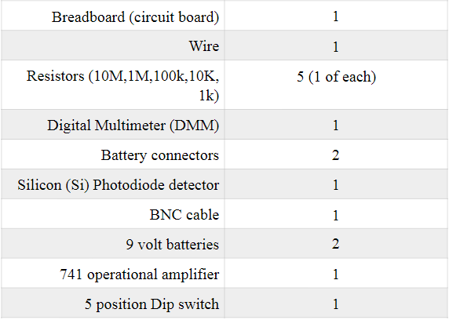

Table 2. Resistance/Gain Measurements

|  |  |  |  |
| --- | --- | --- | --- |
| **Idealized** | **Measured** | **Vout (V)** | **Calculated Current (*μ*A)** |
| 1kΩ | 1004.6 Ω | 0.494 | 491.74 |
| 10kΩ | 10061 Ω | 0.51 | 50.69 |
| 100kΩ | 99495 Ω | 0.831 | 8.35 |
| 1MΩ | 1003250 Ω | 7.971 | 7.94 |
| 10MΩ | 9876500 Ω | 8.366 | 0.847 |

Table 3. Linearity Analysis

|  |  |  |  |
| --- | --- | --- | --- |
| **Filter Combination** | **ND Total** | **Voltage measured (V)** | **10*(-ND)*** |
| No Filter | 0 | 5.01 | NA |
| 1 | 0.11 | 4.28 | 0.776 |
| 2 | 0.21 | 3.75 | 0.617 |
| 4 | 0.4 | 2.9 | 0.398 |
| 7 | 0.7 | 2.01 | 0.2 |
| 1,2 | 0.32 | 3.21 | 0.479 |
| 2,4 | 0.61 | 2.2 | 0.245 |
| 2,7 | 0.91 | 1.56 | 0.123 |
| 2,4,7 | 1.1 | 0.952 | 0.079 |

Table 4. Dark Current Analysis

|  |  |  |  |
| --- | --- | --- | --- |
| **Idealized** | **Measured** | **Dark Voltage (mV)** | **Dark Current (A)** |
| 1kΩ | 1004.6 Ω | 487 | 4.85E-4 |
| 10kΩ | 10061 Ω | 436.7 | 4.34E-5 |
| 100kΩ | 99495 Ω | 78.8 | 7.92E-7 |
| 1MΩ | 1003250 Ω | 29.2 | 2.91E-8 |
| 10MΩ | 9876500 Ω | 275 | 2.784E-8 |

Table 5. Inverse Square Law Analysis

|  |  |  |  |
| --- | --- | --- | --- |
| **Reading Number** | **Distance from Source (cm)** | **Voltage Reading (V)** | **Predicted Voltage** |
| 0 | 8 | 4.31 | 4.31 |
| 1 | 9 | 3.59 | 3.405432099 |
| 2 | 10 | 3.02 | 2.7584 |
| 3 | 11 | 2.60 | 2.279669421 |
| 4 | 12 | 2.27 | 1.915555556 |
| 5 | 13 | 2.02 | 1.632189349 |
| 6 | 14 | 1.81 | 1.407346939 |
| 7 | 15 | 1.64 | 1.225955556 |
| 8 | 16 | 1.50 | 1.0775 |
| 9 | 17 | 1.39 | 0.9544636678 |
| 10 | 18 | 1.29 | 0.8513580247 |
| 11 | 19 | 1.21 | 0.764099723 |
| 12 | 20 | 1.14 | 0.6896 |
| 13 | 21 | 1.08 | 0.6254875283 |
| 14 | 22 | 1.03 | 0.5699173554 |
| 15 | 23 | 0.99 | 0.521436673 |
| 16 | 24 | 0.94 | 0.4788888889 |
| 17 | 25 | 0.91 | 0.441344 |
| 18 | 26 | 0.88 | 0.4080473373 |
| 19 | 27 | 0.85 | 0.3783813443 |
| 20 | 28 | 0.83 | 0.3518367347 |

**REFERENCES**

1. Bachmann, C. and Hughes, E., “Building and Using Your Own Radiometer”, Rochester Institute of Technology (2019).
2. Wikipedia contributors, "Coefficient of determination," *Wikipedia, The Free Encyclopedia,* https://en.wikipedia.org/w/index.php?title=Coefficient_of_determination&oldid=915673702 (September 15, 2019).